IAM System Technical Specification

By Zexin Lin

1. Subject description
2. Subject analysis
   1. Major features
   2. Application Feasibility
   3. Data description
   4. Expected results
   5. Algorithms study
   6. Scope of the application (limits, evolutions)
3. Conception
   1. Chosen algorithm
   2. Data structures
   3. Global application flow
   4. Global schema and major features schema
4. Console operations description
   1. <One section by operation>
5. Configuration instructions
6. Commented Screenshots
7. Bibliography

1. Subject description

The IAM Project is mainly aimed at managing users of an Information System. The functions of the application should cover the following:

Create, delete, modify and search for (by multiple criteria) identity information.

Persist user data in a database

Provide a user-friendly interface, which in my case is a website.

Be robust, capable of good performance

2. Subject analysis

2.1. Major features

Manage authentication for the users

Query from the database to get the corresponding password for the current login, then check with the password submitted by the user. The security mechanism should be the main concern.

Manage the public common attributes for all identity

The system should be able to load the attribute list from the database first. Users can view, add and delete the field from the table, which provide the convenience for users to manage the information dynamically.

Manage the private attribute for certain identity

User can customize the extra information for any user.

Create an identity

Insert a new identity to the table holding identity information in the database

Delete an identity

Delete an existing identity from database with specified id

Update an identity

Update identity information

Search for identities by multiple criteria

Users can specify multiple criteria according to the current attribute list to search for related identities.

2.2. Application feasibility

Strength:

Any cooperation nowadays can’t survive without a reliable and efficient Information Management System.

All the features can easily be achieved.

Weakness:

How to make the system robust and capable of high-performance remains a challenge.

How to guarantee the security of the system required professional skill on the related field.

2.3. Data description

The system mainly persists two kinds of data, User who manage and Identity who are managed.

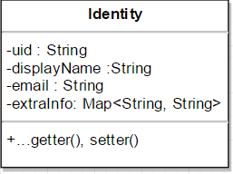

MySQL database is used to implement data access and persist.

Database db_iam consist of three tables: 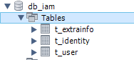

t_user: Manage the user data including username, password and some security-related fields.

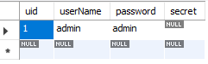

t_identity: Manage public identity information.

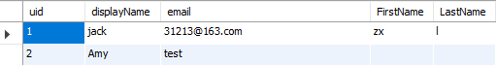

t_extrainfo: Manage private identity information owned by certain user



2.4. Expected result

Define the entity model

Implement reliable DAO interface to persist data in the database

Implement main features mentions above using MVC design pattern.

Provide user-friendly interface

Make the system robust and capable of high-performance

2.5. Scope of the application

This application can fulfill the basic functions for the identity management, covering user authentication, access and modification of identity information dynamically.

Limits:

Can’t hold big data volume, no sorting and searching algorithm used.

3.Conception

3.1. Data structure

Only the Identity class is defined.



Within the Identity class, the Map data structure is used to contain all attribute to value pairs which cooperates with the dynamic modification of identity attributes.

3.2. Global application flow

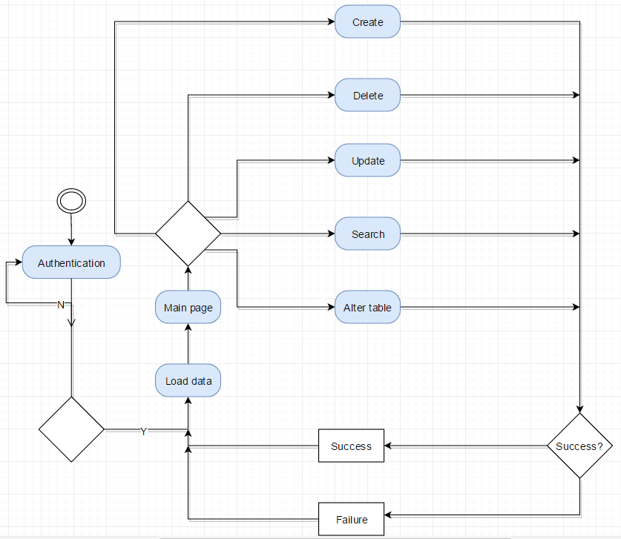

3.3. Global schema and major features schema

Java Package structure for backend: 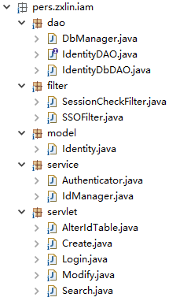

Model Package defines entity class Identity to be maintained. DAO Package regulates the IdentityDAO interface for accessing and motifying Identity class, and also contains the implementation based on MySQL database. Service Package implements main features using DAO interface, and provides interface for UI layer to invoke. Servelet Package include several servlets in charge of different functions. Filter Package requsts from user.

Web content: 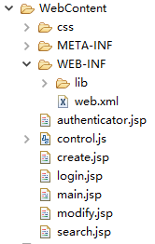

Following schema shows the structure of the application

